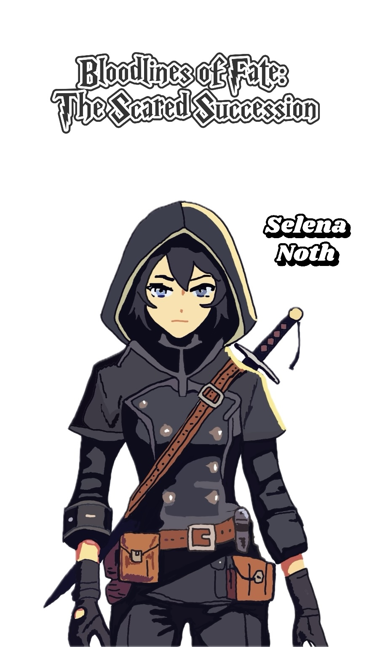

Selena Noth Player Handbook
1. The setting of the story and the present
Tensions are high on a land that is split between the Nagari Tribe, the Falor Theocracy, and the Caldean Kingdom. There is total monarchy in the Caldean Kingdom, and people believe in the holy "Blood of the King," which makes their rule legal. Prince Alfred is about to take the throne because the next "Sacred Lion Succession Ceremony" is coming up in ten days.

A century ago, people broke away from Caldean and started the Falor Theocracy because they believed in equal rights for everyone. Even though Falor was built on ideals, it is now filled with unfairness, power battles, and the rise of extremist groups.

The Nagari Tribe was formed twenty years ago when Caldean slaves rose up against their masters. Now, the tribe lives a nomadic life in the woods, fighting Caldean forces often as they try to get freedom.

2. Information about the player character
Who You Are:
As a part of Edric Noth's intelligence network, Selena Noth is known for having a sharp mind, thinking strategically, and being completely loyal to Edric. You were raised as a Falor member and strongly believe in its teachings of equality. As a child, you learned to value truth and justice, and you were taught to look out for Falor's best interests. But because you work for the spy network, you've seen the bad side of politics, both inside and outside of Falor.

Background and past events:
You were born into Falor and grew up in the desert, which was hard. In Falor, life wasn't always easy. There weren't many supplies, and it was hot and dry in the desert. Your parents were among the people who ran away from Caldean to find freedom. They talked a lot about the unfair things that happened to them, which made you hate the oppressive systems that kept Caldean's moral superiority. This made you even more determined to serve Falor, the country that was a symbol of hope for everyone who was looking for equality.

You were always aware as a child. You quickly learned to pick up on things other people missed, like body language, facial expressions, and goals that were not said. Edric Noth noticed how aware you were and thought you had promise. He started to personally oversee your training. It was under his direction that you learned how to spy, lie, and plan. You learned that information is power and that having it could change the course of history.

For years, you had a strong faith in Falor's ideas and were fully committed to Edric's vision of equality. You did secret missions, getting information from Caldean and keeping an eye on the enemy's movements. Your tasks were dangerous, but you did them perfectly, which is why Edric thinks of you as his trusted friend. Inside Caldean towns, you listened at the doors of nobles and brought back useful information to Falor.

That being said, as you learned more about Falor's spy network, you started to see problems with the doctrine you used to believe in. While the leaders said they believed in equality, there seemed to be an unwritten hierarchy in place. Women had never been picked as Popes or rulers. Edric was nice to you, but you noticed that other leaders often didn't care about your ideas because you were a woman. You started to think, "Is Falor really different from Caldean?" Is this country of "equality" really just another way to control people?

These thoughts have made you feel uneasy, but you have kept them to yourself because you know that telling anyone could put your life in danger. You are also becoming less loyal to Edric. You admire his drive and vision, but you have also seen the cruel side of him—the part that is ready to kill anyone, even innocent people, to reach his goals. Since your tasks have brought you close to the people of Caldean, you know that not all of them are bad. A lot of regular people are just trying to get by, just like the people of Falor. You're starting to wonder if the way to equality has to be made with blood all the time.
Even though these questions were asked, you have continued to do your job well. As long as you stay calm, you always act like the trustworthy servant that Edric wants you to be. You're waiting for the right time to decide what you will do about your future and your loyalty. You have to decide if you want to keep following Edric's radical idea or go your own way.

3. How to Hide Things
Your increasing doubts about Falor's teachings and Edric's ways must be kept secret from everyone. Edric has also given you a secret mission: find out what's really going on with Caldean's "Blood of the King." This task is very important to Edric's plans, and he can't fail. Talk has been going around about a secret that only the Caldean King and his replacement know. You are determined to find out what that secret is, even if it means taking a lot of risks.

4. Thoughts on Other Player Characters
Alfred Caldean is the prince of Caldean right now and will soon take the throne. He is cocky, spoiled, and sure that his family is better than everyone else's. He is everything you were told to dislike. Still, you have seen signs of weakness during your intelligence tasks. You're curious about him and don't want to let your feelings get in the way of your judgment.

Elias Caldean is the son of Leo Caldean, who took a side with Falor. You've never known much about him. You know his dad knows a lot of things, and you think Elias may also know more than he's telling you. He is smart and careful, and you still don't know where his true interests lie. You are wary of him because he seems so calm, and you keep a close eye on him because you don't know if he will be a friend or a threat.

Arya Amir is the daughter of the leader of the Nagari Tribe. You are interested in her because she seems honest and fair. She really wants to help her people, and unlike many others, she doesn't have anything bad to say about you. You think she has a lot of promise. She might be able to help you because she isn't affected by the politics of Caldean or Falor. You know she is naive, though, which could be a problem.

The reliable guard for Alfred is Gareth Reynolds. He loves the royal family very much and will always do what's right to protect them. Him being someone who will do anything to protect the throne makes you see him as a big problem. You are trying to break down everything about Caldean that he represents, and you know that if he finds out your real goal, he will turn into a dangerous enemy.

5. Goals for Character
The public goal is to be loyal to Edric Noth, learn more about the Caldean royal family, and look out for Falor's best interests.
Secret Goal: You want to find out what the "Blood of the King" really means and whether it's a source of power or just a lie to keep people in line. At the same time, you are having your own questions about Falor's teachings and your part in Edric's plans. You have to choose whether to keep working for Edric even though you know his ways may not be in line with the values you used to hold dear, or to start a new path that really supports fairness and equality.

